Year 8
Summer 1
English
Homework Booklet
A Midsummer Night’s Dream
William Shakespeare
Name: _ ___________________
Teacher: ______ _____________
Date of issue: _______ ________
Date Due back in: _______ ______
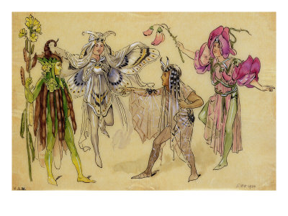
English Assessment and Written Feedback
Year 8 Homework Booklet Summer I W/C: 22nd April

Name:
These grades are recorded in GO. | Target Grade: | Current Grade:
Criteria: WRITING ASSESSMENT FOCUSES
RAF 3 – Reading between the lines to interpret meaning.
RAF 5 – Explain why writers use certain words and sentences to create meaning.
RAF6 – Identify and comment on a writer’s purpose and viewpoint.
WAF6 - use grammar and punctuation accurately.
WAF8 – spelling.
What you did well (Green)  Targets to improve further (Red)  RAF3:  - I can read between the lines for hidden meanings and explain these meanings using quotations as evidence (L5)  RAF 5:  - I can explain the effects of some of the writer’s word and sentence choices & what meanings the writer is trying to show the reader (L5)  RAF6:  - I can identify the main purpose of a text (L5)  - I can explain a writer’s viewpoint (L5)  - I am aware of how a text might affect a reader (L5)  WAF6:  - I use the full range of punctuation correctly (L5)  WAF 8:  - I can spell most words correctly (L5)  - I make errors occasionally (L5) |  |  | How to improve:
Student Response
Note here anything you are not sure about:

Use this space to record your personal targets:

Task 1: KEY WORDS (WAF8 – spelling).
Look up these key words and write a definition below. Remember to use capital letters to begin sentences.

Word | Definition
Character
Theme
Stagecraft
Playwright
Midsummer
Dispute
Authority
Metaphor
Patriarchal
Infatuation

Task 2: Letter writing.
WAF6- Grammar & Punctuation.
Task: Imagine you have been arguing with a parent/ guardian about your choice of boyfriend/ girlfriend. Write a letter to an advice column asking for help. Include:
Paragraph 1: An introduction to explain the problem.
Paragraph 2: How you feel about the situation.
Paragraph 3: How you think your parent/ guardian feels about the situation.
Paragraph 4: How your boyfriend/ girlfriend feels.
Paragraph 5: A final plea for help.

Remember to:
- Write in first person
- Take care with paragraphs.
- Check your spelling
- Use punctuation and capital letters.

Write on a separate piece of paper. Set your letter out in the correct format.

(Your address)
Neale-Wade Academy
March
PE15 9PX
(Their address)
Dr A Gonyaunt
TV Quick Magazine
London
N1 9PL

22nd April 2013

Dear Dr,

Yours sincerely,

Task 3: Design a poster advertising a performance of A Midsummer Night’s Dream.
You should include the dates of performances, the venue and the times of performances. (Remember that Shakespeare’s plays were performed in daylight as the Elizabethan’s didn’t have electricity).
You should choose actors to play the leading characters and list them on the poster.
Check your spellings and capital letters, especially for the name of the play and the playwright.
Task 4: This is a picture of the Globe Theatre. Research the theatre and add comments, (like the example about the roof), to the stage and audience areas.
No roof so the audience would get wet.

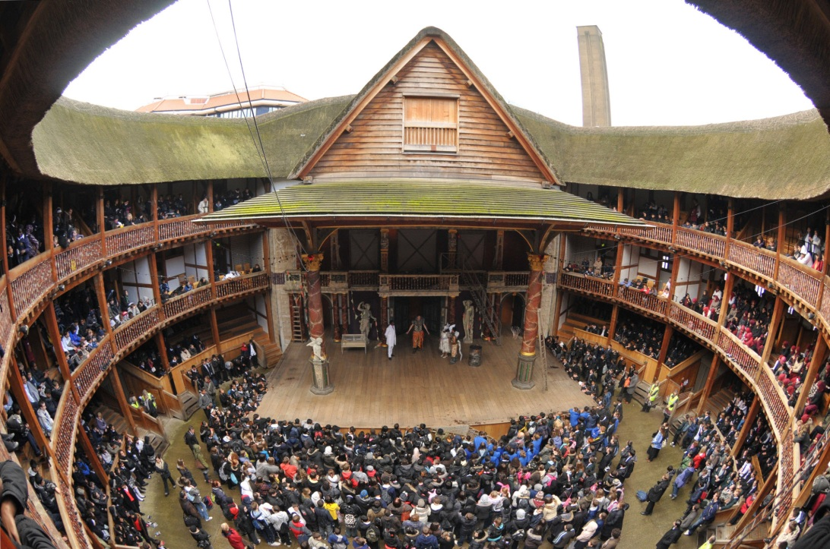

Task 5:
Draw or print designs/ ideas for costumes for two of the characters. Write a few lines with each picture to explain why you have chosen them.
For example,
Titania, Queen of Fairies.
Titania would wear a dress with sparkles on as it represents stars and night time.
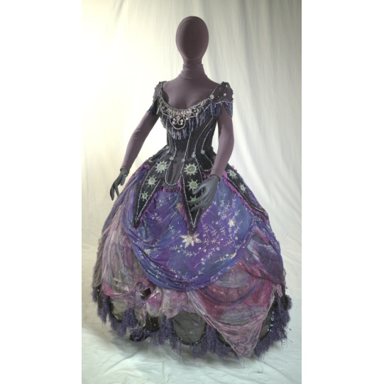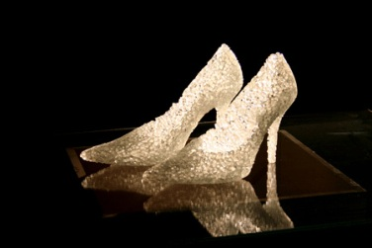
She would wear glass shoes as she is a fairy and doesn’t really need practical footwear because she can fly or float.
You can add to this one for Titania or start your own…

Optional ExtensionTask : There is a problem…fill in the table below.
Theseus is the Duke. Egeus is Hermia’s father. Hermia loves Lysander. Demetrius and Lysander both love Hermia.
A This man hath my consent to marry her… B I would my father look’d but with my eyes!
C …Or else the law of Athens yields you up,
Which by no means we may extenuate,
To death, or to vow a single life. D This man hath bewitched the bosom of my child…

E But I beseech your Grace, that I may know F You have her father’s love Demetrius;
The worst that may befall me in this case, Let me have Hermia’s;
If I refuse..?

 | Who says? | To/about whom? | Meaning?
A
B
C
D
E
F

