Mud review: Matthew McConaughey and Reese Witherspoon dazzle in captivating and classy drama
12 May 2013 00:00
It's a cinematic treat, brimming with a sense of Southern charm and balanced by a haunting notion that something dark is waiting in the wings

****
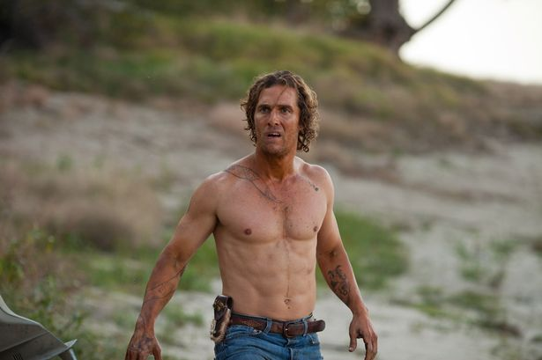Wallowing in the Mud: McConaughey is superb
The stars
Matthew McConaughey, Reese Witherspoon, Tye Sheridan, Jacob Lofland, Sam Shepard
The story
In Arkansas, on the banks of the Mississippi, 14-year-old Ellis (Sheridan) and his best friend Neckbone (Lofland) head out to explore an island when they come across a boat suspended in a tree.
They find a mysterious man named Mud (McConaughey) living in the boat and are drawn into his complex world.
He is wanted by police for murdering a man who beat his girlfriend (Witherspoon) and is also being pursued by the dead man’s family.
The verdict
A beautifully made and almost classic bit of old-fashioned storytelling, coming-of-age film Mud is a cinematic treat... a slow-burning, highly satisfying drama that is defined by a rich atmosphere and a series of strong performances.
Brimming with a sense of Southern charm, balanced by a haunting notion that something dark is waiting in the wings, the film embraces the Americana of stories like Huckleberry Finn and To Kill A Mockingbird as it revels in its dense and sultry atmosphere.
And with a strong cast headed by Matthew McConaughey (who seems to get better and better as an actor) and Reese Witherspoon, it calls out to be appreciated.
To a degree, the film is about the teenagers who find the superstitious and oddly charismatic Mud hiding out and develop a friendship with him. Tye Sheridan and Jacob Lofland are quite wonderful as the boys who do all they can to reunite him with his lost love.
Writer-director Jeff Nichols (who made cult films Take Shelter and Shotgun Stories) wrote the film with McConaughey very much in mind and the actor clearly relishes the quirky and charming role, delivering a performance that’s both captivating and complex.
Mud might feel old fashioned and familiar but it is also a delicate and atmospheric film rarely made by Hollywood these days.

