**Of Mice and Men Speaking Test**

**FOUNDATION**

1. Who wrote the novel? John Steinbeck
2. Where did he set the novel? The Salinas valley, in Soledad, California
3. When did he set the novel? After the Wall Street Crash in 1929
4. What was the result of the American Depression?
5. The Depression in America crippled the country from 1930 - 1936.
6. People lost their life savings when firms and banks went bust
7. 15 million men and women - one third of America's population - were unemployed.
8. There was then no dole to fall back on, so food was short and the unemployed in cities couldn't pay their rent.
9. What does it mean to be an itinerant worker? Move from farm to farm working in the fields. George describes ranch workers as “the loneliest guys in the world” with “no family” and “nothing to look ahead to.”
10. What is alfafa? A pea plant that is perennial
11. What is a jerkline skinner? Slim’s job means you he had to control the reins of the horses
12. What does it mean to be a ranch hand? Someone employed to work on the farm.
13. Where do ranch hands live? They live in a bunk house; poor accommodation blocks which were often barns.
14. How is the story narrated? Third person, omniscient narrator which means all of the characters’ perspectives can be explored through the story.
15. Why is the novella called ‘Of Mice and Men’? It is based on the poem by Burns about a nurse who carefully makes their nest in a wheat field, only for it to be destroyed by a ploughman. It foreshadows what how tragic our lives can be.
16. What ideas/themes are present in the novella?
17. Friendship
18. The Predatory Nature of Human Existence
19. The Impossibility of the American Dream
20. The Corrupting Power of Women/Sexism/Marriage
21. Loneliness/Companionship/Isolation
22. Strength and Weakness
23. Racism
24. Growing old
25. Economics
26. Hope (lack thereof)
27. The lifestyle of itinerant workers
28. What is George and Lennie’s Farm symbolic of? Freedom and independence
29. What is Candy’s dog symbolic of? Candy’s future if he cannot work.
30. What is the setting symbolic of? The isolation (Soledad means this) of the characters.
31. How is this novel structured? Six sections that open with descriptions. The novel is circular as it returns to the opening setting: the brush.
32. What devices does Steinbeck use in his description? Onomatopoeia, Metaphor, Simile, Imagery, Personification, Sibilance, SENSORY description.
33. Will the men stay on the ranch? The men on the ranch are all passing through except Candy and Crooks who are forced to stay because of their disabilities.
34. Why do the men go into town when they are paid? No-one seems to have a family and they all go to town to pay for the temporary company of women.

**INTERMEDIATE**

1. How is George presented in ‘Of Mice and Men’?

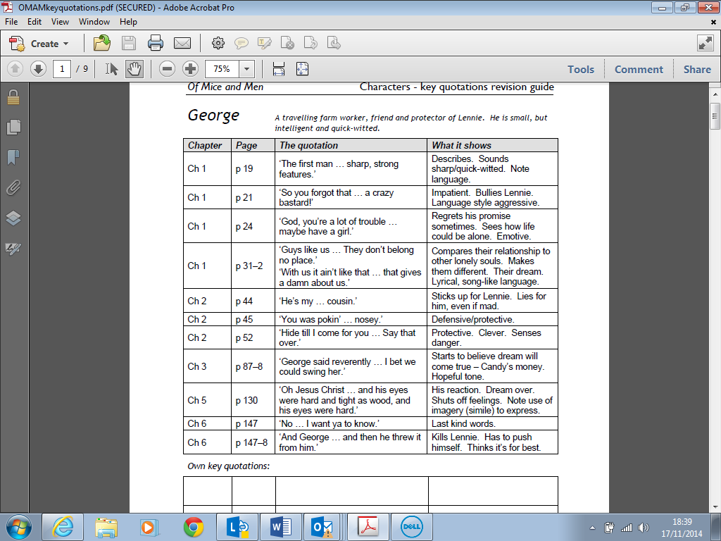

1. How is Lennie presented in ‘Of Mice and Men’?

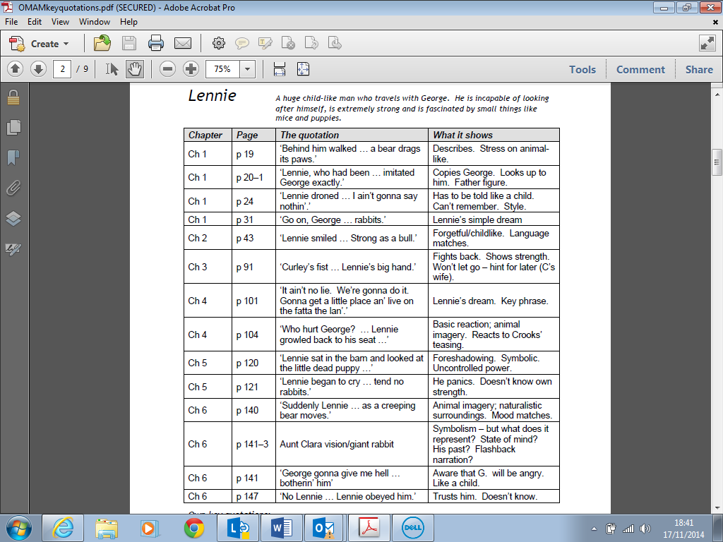

1. How is Crooks presented in ‘Of Mice and Men’?

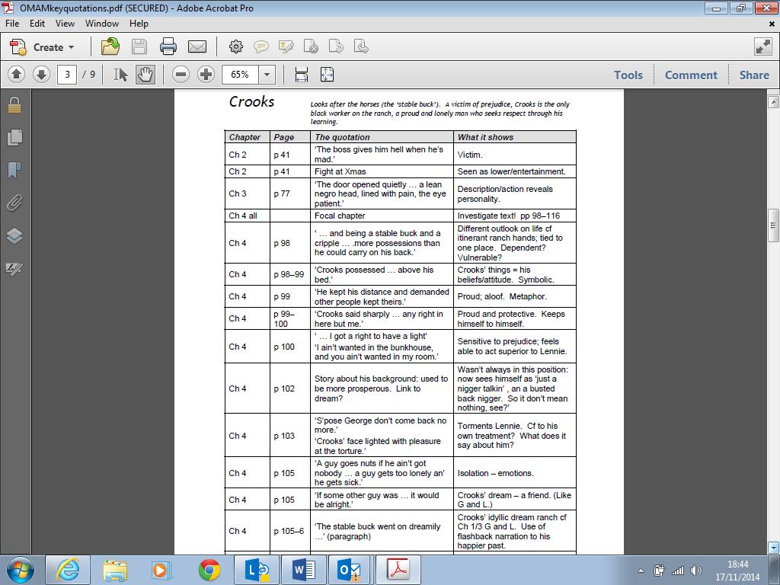

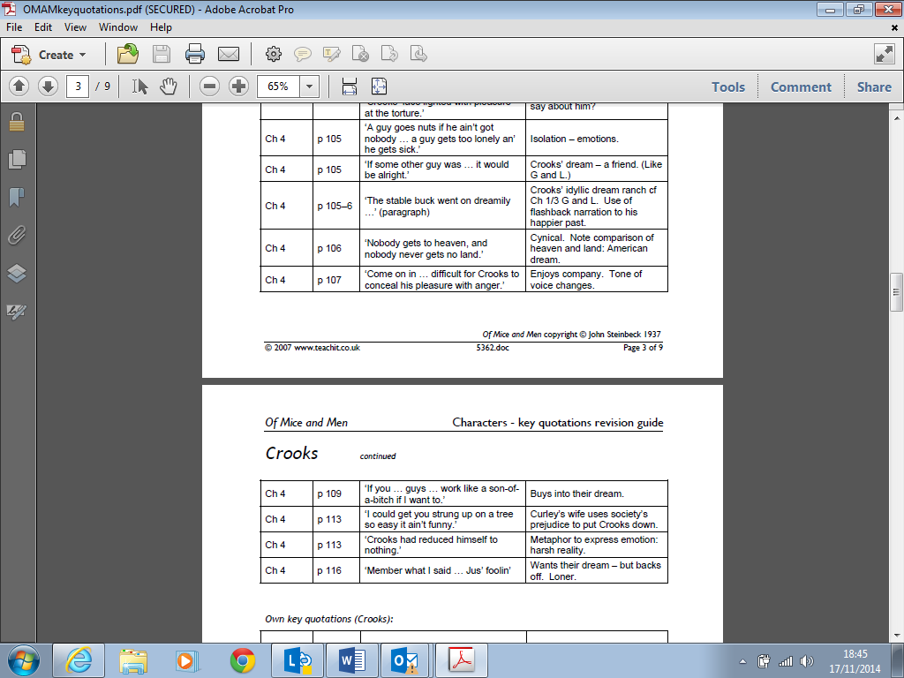



1. How is Curley’s wife presented in ‘Of Mice and Men’?

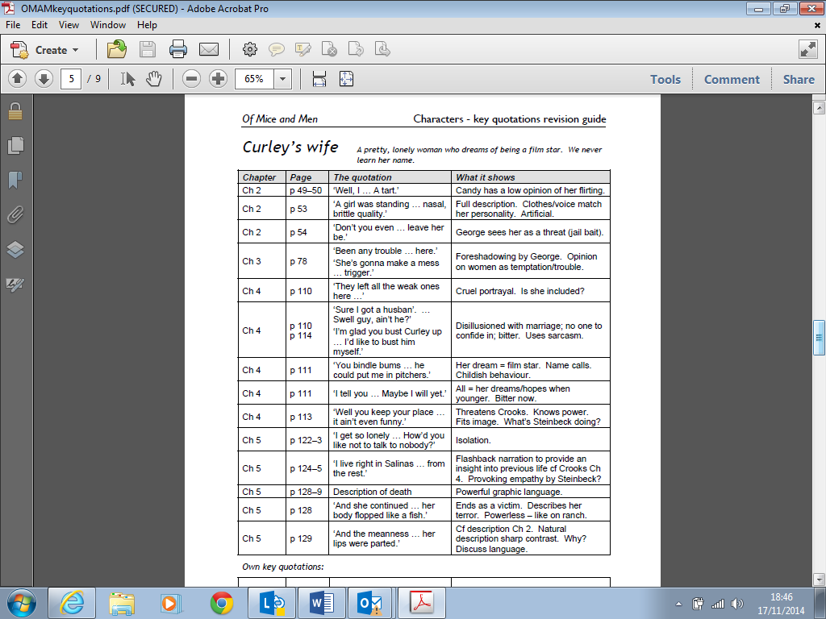

1. How is Curley presented in ‘Of Mice and Men’?

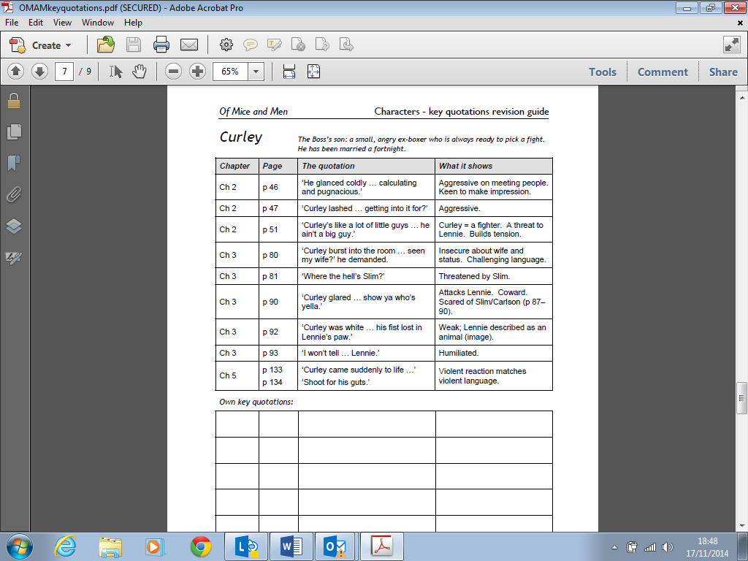

1. How is Slim presented in ‘Of Mice and Men’?

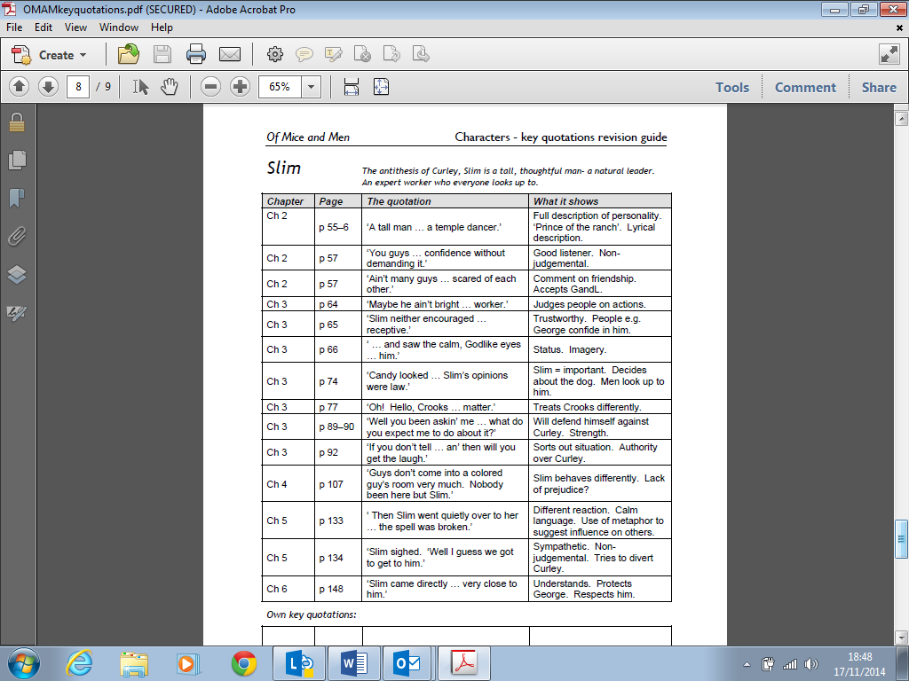

**ADVANCED**

**Complete a GCSE exam question**

**EXAM TIP:**

You will have one extract based question (provided by your teacher or in your literature revision pack). This is worth 10 marks and for the last few years has been: **What do you think about the way [character’s name] speaks and behaves here? The higher question is basically the same but phrased as: Look closely at how [character’s name] speaks and behaves here? How does it affect your feelings towards him?**

Then you will have a choice of two questions: one will be an empathy question and one will be a character/theme question. DO NOT DO THE EMPATHY QUESTION – the marking of it is too subjective.

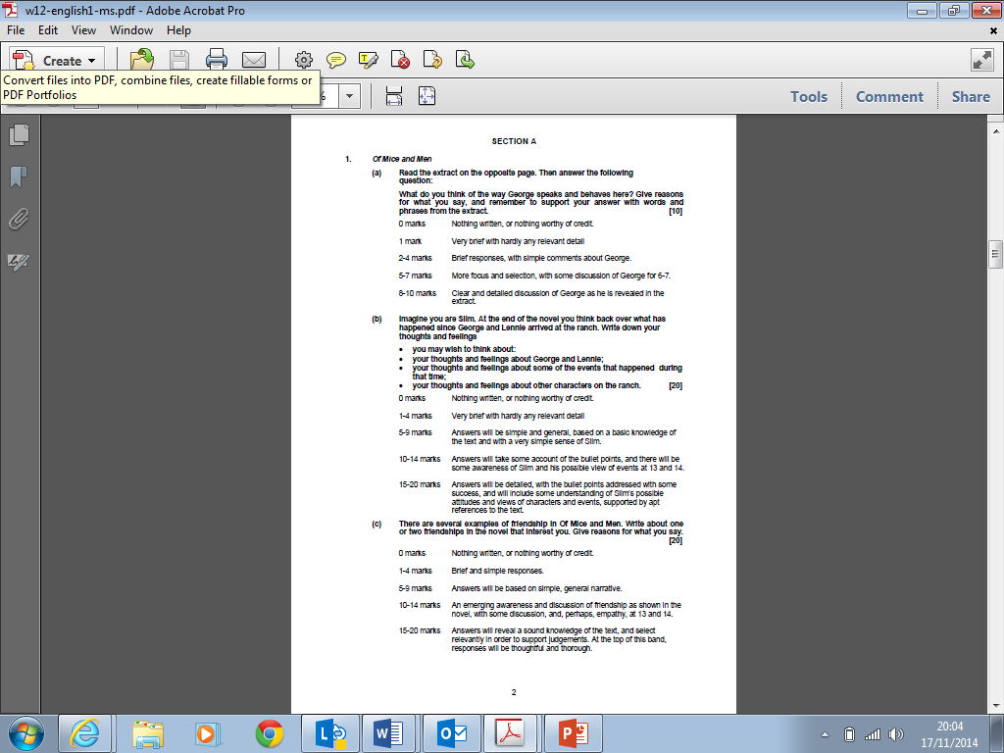

**MARKSCHEME**

