Year 10 Autumn 1
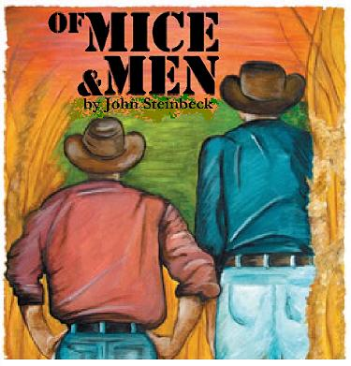
Homework Booklet

Of Mice and Men
John Steinbeck

Name: ______________________
Teacher: _____________________
Date of issue: _________________
Date Due back in: ______________

English Assessment and Written Feedback

Name:
These grades are recorded in GO. | Target Grade: | Current Grade:
Criteria:

What you did well (Green)  Targets to improve further (Red) |  |  | How to improve:
Student Response
Note here anything you are not sure about:

What are your personal targets:

Week 1

Write the opening page of a novel set in the countryside. It should have lots of natural description and you should try to use some symbolism.
Do not write a story, just focus on description with some minimal dialogue.
Base it on ‘Of Mice and Men’ by using the following elements. Handwrite it or type it up.

- Two friends walking together.
- A place of natural beauty with animals.
- A shared dream (perhaps a particular job or country house or something else).

My Novel Opening
High over the glistening mountain tops, the sun, hazy but warm, gazed down on the dusty road…

WEEK 2

In class you have started to focus on how characters are created.

You are going to write as EITHER the character of George or Lennie in the First Person. Use language that your character would use. This is especially important with Lennie.

Imagine both men can write and are describing their first night at the Ranch in a diary. Focus on 3 areas.

- What are your hopes and fears?
- What do you think of the other men there?
- Do you think you will ever achieve your dream?

George or Lennie’s Diary
Week 3
The ranch has wide range of contrasting characters. Create a new character by firstly describing him/her and then by sketching him/her in the space below. Include:
- Physical appearance
- Attitude towards others
- His/her possessions

Week 4
Curley’s wife has now been introduced. Research Women in 1930’s America. Find 10 facts about women and their position in society. This might include their rights, the type of jobs they would do, expectations of men and so on. Make a comprehensive list in the space below and use a separate sheet if necessary.

1
2
3
4
5
6
7
8
9
10
Useful website: http://www.gilderlehrman.org/history-by-era/great-depression/essays/women-and-great-depression

Week 5

In class you will be almost at the end of the novel or you may have finished it.
Imagine you were defending one of the characters in a court-case. How would convince a judge of their innocence?

Pick one of the following characters and write a page explaining that they were not to blame for the final events in the book. You MUST provide evidence to back up your ideas.

For example, if you think that Lennie is not to blame for the death of Curley’s Wife, you must try to prove it using evidence from the text.

The Characters
- George
- Lennie
- Curley’s Wife

As an alternative task – imagine you are the prosecution and are trying to convince a judge that one of the above characters is to blame.
Some quotes you could use:

George:
“I think I knowed from the very first…”
“If I was a relative of yours I’d shoot myself…”

Lennie:
“They run us outta Weed…”
“Leggo of him, Lennie. Let go.”
“She’s purty.”

Curley’s wife:
Her face was heavily made up. Her lips were slightly parted.
“You all scared of each other, that’s what…”
“Feel right aroun’ there an’ see how soft it is…”

The Court Case

Week 6

Some people don’t like the ending of the novel.
Write an alternative ending... but make sure you consider the following:

- Ensure your characters are realistic in the way they speak and behave.
- Use the type of description Steinbeck would use. Lots of natural description, light and dark and animals.
- Begin from the action on page 106.
- Think about what other courses of action George could take.

Plan you ending in the space below.

My Alternative Ending
George was transfixed by the lifeless body of Curley’s Wife…..
My Alternative Ending

Parent’s Log

Week | Questions or comments | Signature

