**Year 7 Homework Booklet**

**Myths and Legends**

Name: _______________________

Teacher: _____________________

Date of issue: _________________

Date Due back in: ______________

You may not have to complete every task in this booklet; listen carefully to your teacher’s instructions!

Some weeks have a brainstretcher task, designed to make you think a little bit harder. These tasks are not compulsory; have a go if you feel that the homework was just a bit ‘easy-peasy’ for you! Look out for the brain!

D:\Documents and Settings\Administrator.JANES-LAPTOP\My Documents\My Pictures\Microsoft Clip Organizer\00055181.wmf

|  |
| --- |
| **English**  **Assessment** |
| What went well…?: |
| Even better if…?: |
| What I think…? |
| GRADE: EXCELLENT GOOD SATISFACTORY POOR |
| Teacher Comment: |

Task 1

Spellings

First of all, rate your own ability as a speller! Tick the word that best describes your level of spelling. Be honest!

* Excellent
* Very good
* Good
* Average
* Not very good

This week’s task is to learn some spellings related to myths and legends. There are 10 spellings. Every student should try really hard to learn the first 5; if you rated yourself as good or better, then try to learn up to 10. Use the table, and ‘look, cover, write, check’ to help learn the words.

|  |  |  |  |
| --- | --- | --- | --- |
| LOOK | WRITE | CHECK | TRY AGAIN? |
| legend |  |  |  |
| myth |  |  |  |
| journey |  |  |  |
| creature |  |  |  |
| Olympus |  |  |  |
| convention |  |  |  |
| Theseus |  |  |  |
| Minotaur |  |  |  |
| mythical |  |  |  |
| legendary |  |  |  |

D:\Documents and Settings\Administrator.JANES-LAPTOP\My Documents\My Pictures\Microsoft Clip Organizer\00055181.wmf Brain s t r e t c h e r!

Did you know the meaning of all of the words? Write two sentences, one using ‘mythical’, and one using ‘convention’.

________________________________________________________________________________________________________

Task 2

This week you need to think about mythical creatures. Examples of mythical creatures are a mermaid and a phoenix. Mythical creatures can be made of more than one creature and they often have magical powers.

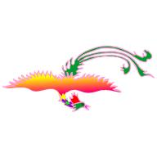 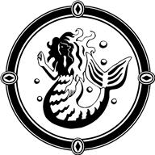

Your task is to invent a new mythical creature. It could be made up of more than one real creature; how about a bat and a spider, or an octopus and a cat?

Your creature needs a name, you have to write three sentences describing it, and you need to draw a picture of it.

My mythical creature’s name is: ___________________________________

A Description of My Creature: (Write at least three sentences.)

___________________________________________________________________________________________________________________________________________________________________________________________________________________________________________________________________________________________________________________________________________________________________________________________________________________________________________

Task 3

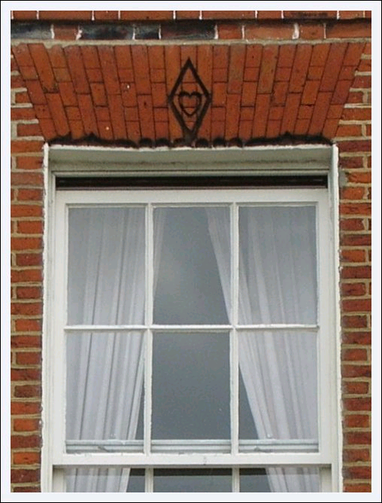

**LOCAL LEGENDS: THE KING’S LYNN HEART**

The picture shows the window of a building on the Tuesday Market Place in King’s Lynn. Above the window is a crudely carved heart. Legend says that this was carved to mark the place where the wall was struck by a real, beating, human heart!

In 1590 a local woman, Margaret Read, was accused of witchcraft. She was found guilty on very flimsy evidence: she lived alone and kept a cat, and was believed to have caused her neighbour’s animals to become ill and die.

In those days the punishment for witchcraft was death, and the most effective way to completely destroy the witch’s power was to burn her alive.

Margaret Read was ‘burned at the stake’ – that means that she was tied, alive, to a wooden block and was then set on fire. According to the legend, as she was burning her heart burst out of her body and flew across the market place, striking the building about 12 feet above the ground. Some versions say that her heart then bounced away from the building, all the way down to the nearby River Ouse.

Homework Task

Homework this week is to find out about a local legend and rewrite it in your own words. You could find and print something from the Internet, but you still need to retell the story in your own words. It does not have to be very long. It could be a story that you have been told, rather than something that is written down.

Use the next page to write out your local legend.

Make sure that spelling and punctuation are correct and that the order of your ideas is clear and understandable. Remember to write in paragraphs.

My Local Legend

__________________________________________________________________________________________________________________________________________________________________________________________________________________________________________________________________________________________________________________________________________________________________________________________________________________________________________________________________________________________________________________________________________________________________________________________________________________________________________________________________________________________________________________________________________________________________________________________________________________________________________________________________________________________________________________________________________________________________________________________________________________________

Task 4

Read the story below: 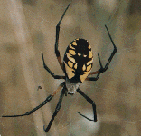

THE STORY OF ARACHNE

Arachne was a girl who lived in [Greece](http://www.historyforkids.org/learn/greeks/) a long, long time ago. She was a very good [weaver](http://www.historyforkids.org/learn/clothing/weaving.htm) and [spinner](http://www.historyforkids.org/learn/clothing/spinning.htm). She [wove](http://www.historyforkids.org/learn/clothing/weaving.htm) all sorts of beautiful [pictures](http://www.historyforkids.org/learn/greeks/art/pottery/blackfigure.htm) into her cloth, and people came from all around to see her beautiful cloth. But Arachne was too proud; she had what the Greeks called [*hubris*](http://www.historyforkids.org/learn/greeks/religion/hubris.htm). (She had too much self-confidence; she was arrogant.)

Arachne began telling people she was better at spinning and weaving than the [goddess](http://www.historyforkids.org/learn/greeks/religion/greekrelig.htm) [Athena](http://www.historyforkids.org/learn/greeks/religion/athena.htm) was. [Athena](http://www.historyforkids.org/learn/greeks/religion/athena.htm) was also known as a good [spinner](http://www.historyforkids.org/learn/clothing/spinning.htm) and [weaver](http://www.historyforkids.org/learn/clothing/greekweaving.htm).

Athena was mad that Arachne would say that, and she challenged Arachne to a weaving contest. The two of them set up their looms in the same [room](http://www.historyforkids.org/learn/greeks/architecture/house.htm) and they wove from early in the morning until it got too dark to see (remember there were no electric [lights](http://www.historyforkids.org/learn/science/light.htm) then!). Then they compared what they had done.

[Athena](http://www.historyforkids.org/learn/greeks/religion/athena.htm) had woven a beautiful cloth showing the [gods and goddesses](http://www.historyforkids.org/learn/greeks/religion/greekrelig.htm) sitting together on Mt. Olympus and doing good deeds for people. But Arachne thought she was so smart, she wove a cloth making fun of the gods and goddesses, showing them getting [drunk](http://www.historyforkids.org/learn/greeks/religion/dionysos.htm) and falling down and making a mess of things. Still, it was clearly better weaving than Athena had done. When [Athena](http://www.historyforkids.org/learn/greeks/religion/athena.htm) saw it she was even more angry than she had been before. Even though Arachne's weaving was better, Athena didn't care. She pointed her finger at Arachne and suddenly Arachne's nose and ears shrank up, her hair all fell out, her arms and legs got long and skinny, and her whole body shrank until she was just a little tiny [spider](http://www.historyforkids.org/learn/greeks/environment/animals.htm) (Arachne means spider in Greek). "You want to spin," cried Athena, "go ahead and spin!"

No matter how skilled people are, they are never any match for the gods. People need to remember their place, and not try to be stronger or wiser or smarter than the gods, or bad things will happen to them.

[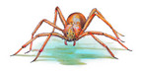](http://www.fotolibra.com/gallery/32619/violin-spider-illustration/)Now you have read the story, turn to the next page to answer some questions.

The Story of Arachne.

* Read the story really carefully and then answer the questions.
* Write in complete sentences.
* Make sure your spelling is correct; use a dictionary if you need to check.

1. What was Arachne skilled at doing?

________________________________________________________________________________________________________

1. What did Arachne do that made Athena angry?

_______________________________________________________________________________________________________

1. What topic did Arachne and Athena both choose for their weaving?

________________________________________________________________________________________________________

1. Whose weaving was better?

____________________________________________________

1. What did Athena do in her temper?

___________________________________________________________________________________________________________

1. What is the moral (message) of this story? Reading the final paragraph of the story again will help you to answer this.

__________________________________________________________________________________________________________­­­­__ D:\Documents and Settings\Administrator.JANES-LAPTOP\My Documents\My Pictures\Microsoft Clip Organizer\00055181.wmf Brain s t r e t c h e r! One extra question …

What is a person called who is really afraid of spiders?

Task 5

Read this British legend and then go on to the next page for the task: C:\Users\JCoe\AppData\Local\Microsoft\Windows\Temporary Internet Files\Content.IE5\TSYKXF40\MC900361630[1].wmf

**The mermaid of Zennor: a legend from Cornwall**

The people of Zennor tell the following story, which, according to them, accounts for a carving on a bench-end in their Church.

Hundreds of years ago a very beautiful and richly attired lady attended service in Zennor Church from time to time.

Whenever she came the people were enchanted with her good looks and sweet singing.

Although Zennor folks were wonderful singers she had a better voice than any of them.

Year after year she visited the Church and everyone wondered how she continued to look so young and fair. People looked out for her but no one could tell where she came from nor where she went.

She took some notice of a fine young man, called Mathey Trewella, who was the best singer in the parish. One day he followed her and didn't come back. After that, the lady was never seen in Zennor Church again, and it might not have been known to this day who or what she was but for the merest accident.

One Sunday morning a vessel cast anchor about a mile from Pendower Cove; soon after a mermaid came close alongside and hailed the ship.

Rising out of the water as far as her waist, with her yellow hair floating around her, the mermaid asked the captain to lift his anchor just for a minute because it rested on her front door, and she was anxious to get in to see her husband Mathey and their children.

When Zennor folks learned that a mermaid dwelt near Pendower, and what she had told the captain, they all knew that it was the same lady who had visited their church. They now knew she had taken Mathy Trewella under the sea with her and that he would never return.

Sometimes, in the evening, folk would sneak down to the cliff tops overlooking Pendower Cove. If they were lucky, and they often were if they waited quietly, they would hear two beautiful voices raised in songs of love, the glorious harmony blending with the wind and waves, soaring up, up towards the heavens.

To remember the mermaid they had her carved into one of their old oak pews, which can still be seen in Zennor Church today.

Go to <http://www.simplystives.co.uk/wp-content/uploads/zennor_mermaid.jpg> to see a photograph of the carving.

Task 5

When you plan a story, you have to think about lots of things. You have to decide on the main events that make up the plot and sort out the order of your ideas.

Use the simple grid below to create a storyboard with words and pictures for ‘The Mermaid of Zennor’.

Remember, you need to select the six main events and put them in the right order.

You can draw the pictures yourself or use pictures from the internet.

|  |  |
| --- | --- |
| 1. **1. Hundreds of years ago, in Zennor, Cornwall, a beautiful lady occasionally attended the service in the village church.** | 2 2. |
| \\nwccbsfvfs001\StaffDocs\JCoe\Pictures\untitled.png\\nwccbsfvfs001\StaffDocs\JCoe\Pictures\church.jpg |  |
| 3 3. | 4 4. |
|  |  |
| 5. | 6. |
|  |  |

Task 6

Pandora’s Box 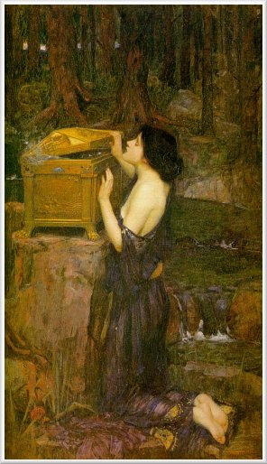

By now, you may have read the story of Pandora’s Box. She is given the box and told not to open it, but she does, and all the ills and evils of the world are released.

If you did not know what was in the box, would **you** have opened it?

Your task this week is to write a letter to Pandora, advising her either to open the box, or to leave well alone.

Remember, you DON’T know what is in the box.

This task focuses on the writing Assessment Focuses for this unit, so you need to:

* Start a new paragraph every time you change topic.
* Think carefully about the order of your ideas.
* Make sure that spelling and punctuation are accurate.
* Advise Pandora what to do: either to open the box and satisfy her curiosity, or to do as she has been told, and leave it closed.
* Use the boxes on the next page to plan your writing.
* Use the lines on the page after that to write your letter.
* Remember to write in paragraphs and check your spelling.

LETTER TO PANDORA

|  |  |  |
| --- | --- | --- |
| PLANNING THE LETTER  Use these boxes for keywords and important ideas. |  | SPELLINGS  Use a dictionary to check spellings you may need. |
| How will you start your letter? Write words and ideas here. | Pandora |
| Advise (verb) |
| In this paragraph you should say what you know about the box. Write your words and ideas here. | Advice (noun) |
|  |
| In this paragraph you should tell Pandora what you think she should do. Write your words and ideas here. |  |
|  |
| In this paragraph you should tell Pandora what you think might happen if she doesn’t take your advice. Write your words and ideas here. |  |
|  |
| End your letter by wishing Pandora well whatever she does. Write your words and ideas here. |  |
|  |

LETTER TO PANDORA

________________________________________________________________________________________________________________________________________________________________________________________________________________________________________________________________________________________________________________________________________________________________________________________________________________________________________________________________________________________________________________________________________________________________________________________________________________________________________________________________________________________________________________________________________________________________________________________________________________________________________________________________________________________________________________________________________________________________________________________________________________________________________________________________________________________________________________________________________________________________________________________________________________________________________________________________________________________________________________________________________________________________________________________________________________________________________________________________________________________________________________________________________________________________________________________________

**Extension Tasks**: These tasks focus on Writing Assessment Focuses 3 and 4: organising, sequencing, using paragraphs and cohesion in your writing.

Task (a): Read the text really carefully and then answer the questions on the next page.

# Giant panda now critical, says new report

The world's most enduring symbol of conservation, the giant panda, has reached a critical point, according to a new report by WWF.

‘Giant Pandas in the Wild’ highlights the continuing devastating impacts of poaching and habitat loss on the species and calls for a permanent fund to be set up to combat chronic financial shortages in China's network of panda reserves. The panda has been WWF's world renowned symbol for 40 years.

Stuart Chapman, head of WWF's species programme, said the panda's plight highlighted the continuing struggle between humans and nature: "The panda is known worldwide as a symbol of conservation, yet its fame hides its small population. There are only 1,000 animals in the wild."

Despite strict penalties in China, the panda is still illegally killed for its pelt. It can also get caught in fatal snares - and, says the report, "conservation is hampered by an overwhelming emphasis on economic development and deficiencies in the government's approach".

The government, argues Stuart Chapman, must urgently create more forest corridors to link isolated panda populations and provide more funds for existing reserves - "otherwise the panda will remain on the brink of extinction."

However, the report reveals that breeding doesn't appear to be a problem for the species in the wild, despite the widespread myth that pandas weren't very interested in reproducing. The problem seems to be that the animal is not keen on breeding in captivity. In 1999 very few of the 126 in captivity were actually involved in breeding.

Added to which, no panda born in captivity has ever been released into the wild. "So the reality is that more pandas are dying than are being born and the captive breeding programme is not making any contribution to wild populations" said Stuart Chapman.

# Questions on the text: Giant panda now critical, says new report

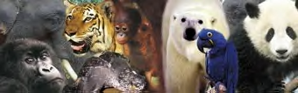

1. How is paragraph 2 effectively linked to paragraph 1?
2. Repetition of words and phrases gives the text cohesion. Find the phrase repeated in paragraphs 1 and 3.
3. Repeated single words give cohesion. What word from the final sentence of paragraph 4 is repeated in the first sentence of paragraph 5?
4. Paragraph 6 moves onto a different topic. Which single word signals this change of subject?
5. Paragraph 7 offers an additional argument. How is this signalled at the beginning of this paragraph?

Move onto the next task if you have completed this task and your teacher has instructed you to complete the extension tasks.

Extension task (b)

Like the previous task, this is an extension task and it is quite tricky.

Read the text, ‘Polar bears Living on Borrowed Time’ on the final page of your homework booklet carefully and then, using the clues below, see if you can sort out the order and number each paragraph correctly.

POLAR BEARS PARAGRAPH SORT TASK 1 CLUES

* Paragraph 2 names the report referred to in the first paragraph.
* The opening sentence of paragraph 3 repeats a key word from the final sentence of paragraph 2.
* Paragraph 4 develops a key topic from paragraph 3, and repeats a phrase from 3.
* Paragraph 6 moves the argument on to look at the action WWF would like.
* Paragraph 7 repeats key words from the final sentence of paragraph 6 in its opening sentence.
* Paragraph 8 sums up, uses different phrase with very similar meaning to ‘climate change’ from paragraph 1 and identifies further threats to polar bears – all in a sentence.



Polar bears living on borrowed time

|  |  |
| --- | --- |
| POLAR BEARS PARAGRAPH SORT TASK | |
| 1 | Climate change is having a dramatic effect on the Arctic and the polar bears that live there, warns a new report by WWF. |
|  | The impacts of global warming come on top of threats that polar bears already face from hunting, toxic pollution and possible oil development in the Arctic. |
|  | Sea ice is the platform from which polar bears hunt their primary prey of ringed seals. Diminishing ice cover and longer ice-free periods would not only limit the hunting time the bears have on the ice, but would also affect their survival during the longer summer season. A two-week extension of the ice-free season could cause an eight per cent weight loss – which in turn would reduce female bears' ability to lactate, leading to greater mortality among cubs. |
|  | According to ‘Polar Bears at Risk’, climate change is the number one long-term threat to the planet's largest land carnivores. This news comes as WWF and the Norwegian Polar Institute launch the world's first website tracking the movements of two polar bears via satellite. |
|  | "As one of the few homes of this magnificent animal, it seems incredible that Canada is dragging its feet over ratifying the Kyoto Treaty," said Dr Ute Collier, Head of WWF-UK's Climate Change Programme. "We cannot ignore the plight of the polar bear because it is symbolic of a global problem which will ultimately affect us all if urgent action isn't taken to curb emissions of greenhouse gases." |
|  | WWF is calling on governments to ratify the Kyoto climate treaty in time for the World Summit on Sustainable Development in August, so that the real fight against climate change can begin. While the UK and other EU countries are committed to Kyoto, Canada – which is home to 60 per cent of the world's polar bears – has so far refused to make its intentions clear. |
|  | The tracking results are expected to reveal important information about how polar bears are reacting to the shrinkage of their critical sea ice habitat. Scientists predict a 60 per cent loss of summer sea ice within 50 years – which means that the summer ice-free season would be more than doubled from 60 to 150 days. |
| 5 | Polar bears in Canada's Hudson Bay have already been hit by climate change, according to Lynn Rosentrater, co-author of the report and WWF's Arctic Climate Scientist. "The sea ice is melting earlier in the spring, and this is sending the polar bears to land earlier without their having developed enough fat reserves," she said. "By the end of the summer, they are skinny and their ability to raise a litter is being jeopardised." |