

**Year 7 Spring 2**

**Writing Non Fiction**

**Homework Booklet**

Name: _______________________

Teacher: _____________________

Date of issue: _________________

Date due back in: ______________

Week 1 Using connectives

You need to use a variety of connectives in your work. Complete the connective grid and learn all the different examples. Colour them according to how often you use them: Green – always; Yellow – sometimes and Red – never.

|  |  |  |  |  |  |  |  |  |  |
| --- | --- | --- | --- | --- | --- | --- | --- | --- | --- |
|  |  |  |  |  |  |  |  |  |  |
|  |  |  |  |  |  |  |  |  |  |
|  |  |  |  |  |  |  |  |  |  |
|  |  |  |  |  | B |  |  |  |  |
|  |  |  |  |  | E |  |  |  |  |
|  |  |  |  |  | C |  |  |  |  |
|  |  |  |  |  | A |  |  |  |  |
|  |  |  |  |  | U |  |  |  |  |
|  |  |  |  |  | S |  |  |  |  |
|  |  |  |  |  | E |  |  |  |  |
|  |  |  |  |  |  |  |  |  |  |
|  |  |  |  |  |  |  |  |  |  |
|  |  |  |  |  |  |  |  |  |  |

|  |  |  |  |
| --- | --- | --- | --- |
| **2 letters**  as  if  or  so | **3 letters**  and  but  **4 letters**  when | **5 letters**  since  while  **6 letters**  before | **7 letters**  because  whether  **8 letters**  although |

|  |  |  |
| --- | --- | --- |
| 1) What is affecting the behaviour of football players?  2) Why is he worries about their behaviour?  3) What does Capello say is the problem with players?  4) Why should players be careful?  5) When did he make his comments?  6) What is your opinion? Why?  Week 2 Reading Non Fiction  One of these questions contains an error. Did you find it?  Read the article and answer the questions in full sentences.  Fabio Capello      **England football boss Fabio Capello says players earn too much money and it's affecting their behaviour away from football.**  The Italian manager reckons footballers must remember they are role models for children and fans.  Capello is worried poor behaviour off the pitch could affect England's World Cup hopes.  Recently footballers John Terry and Ashley Cole have had problems in their private lives.  Capello said in an interview, players should try to behave better: "They are young boys, who are rich boys. This is the problem.  "Players have to be an example to the children, for all the fans. For that reason, they have to stay careful at all times and sacrifice something in their lives."  The England manager has spoken to his team about their behaviour ahead of the team's big match against Egypt at Wembley. | 1) What is affecting the behaviour of football players?  2) Why is he worries about their behaviour?  3) What does Capello say is the problem with players?  4) Why should players be careful?  5) When did he make his comments?  6) What is your opinion? Why? |  |

Week 3 Linking sentences

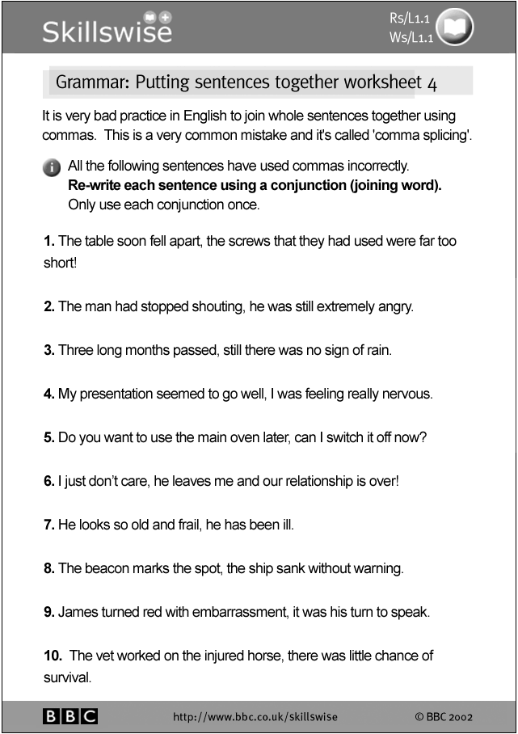

Week 4 Gathering research

Get hold of a newspaper and cut out an article. You must read the article and write out five questions and their answers – in full sentences. Attach the article to this one.

Week 5 Persuasive devices

Charity leaflets are often persuasive and use many devices. Can you look at the example below and identify the devices that it is using? [](http://www.google.co.uk/url?sa=i&source=images&cd=&cad=rja&docid=isPa_joqccUa0M&tbnid=srR9wCBdPJzStM:&ved=0CAUQjRw&url=http%3A%2F%2Fwww.martymccolgan.com%2Fblog%2F&ei=BB7oUfj5KYPBO4T4gNgJ&psig=AFQjCNHuiUMhXwzqkBTi9eO3o6Pkn6EDwA&ust=1374252907083113)

Week 6 Conducting research

Reading is an important skill for life. List all of the different places where you have read over the course of a week. Take pictures of where you read and bring them to class to share.